**Name: ___________________**

**Station 1**

Volume: _______ mL

**Station 2**

Volume: _______ mL

**Station 3**

Volume: _______ mL

**Station 4**

Volume: _______ mL

**Station 5 Station 6**

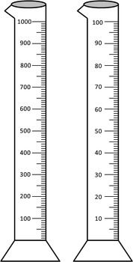Draw the correct Draw the correct  
volume. volume.

\\\

**Station 5**

Draw the correct volume.

65 mL

**Station 6**

Draw the correct volume.

88 mL